**IC 7474 D Flip-Flop Logism Circuit**

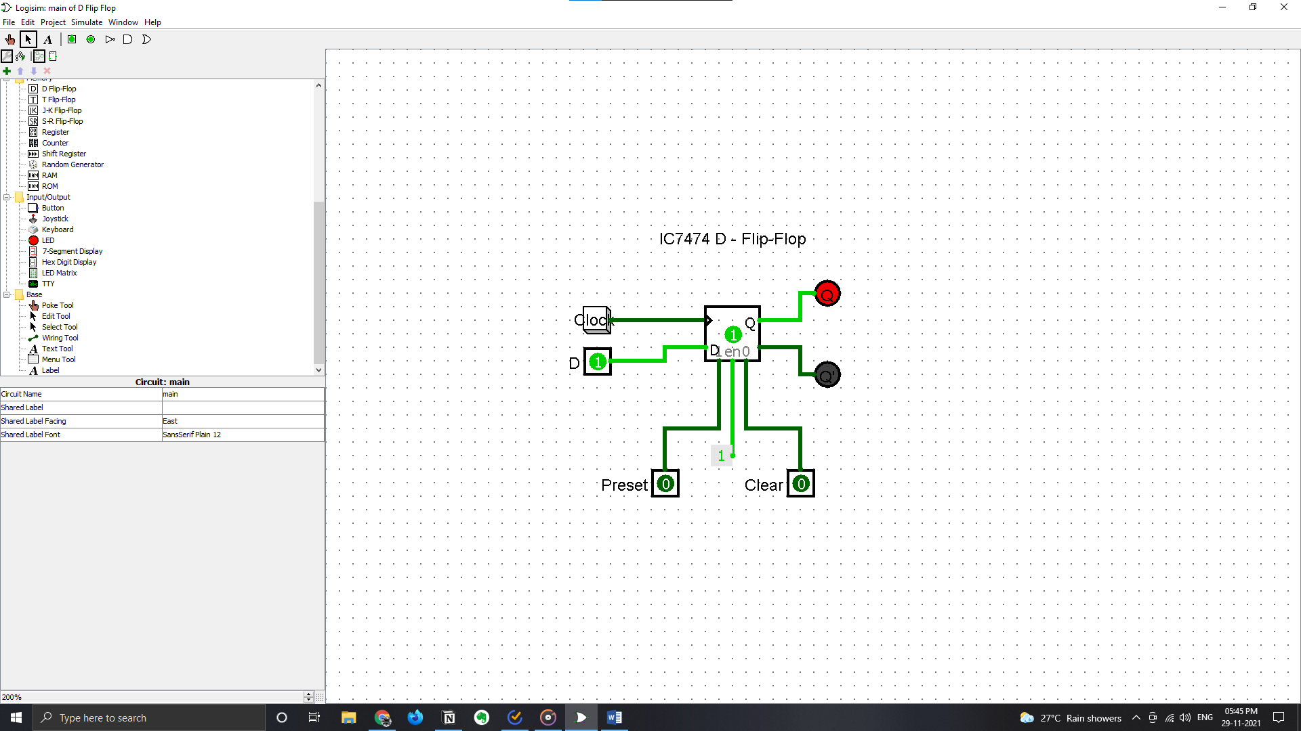

**IC7473 J-K Flip-Flop Logism Circuit**

